**CTF Topic: ASN Autonomous System Lookup**



**1. Introduction**



Autonomous System Number (ASN) lookup is used to identify the owner and operator of a specific IP address or range. This information is crucial for network administrators, cybersecurity analysts, and researchers to understand the network infrastructure and potential threats associated with IP addresses.

**2. Tools and Requirements**

Access to [HackerTarget ASN IP Lookup Tool <https://hackertarget.com/as-ip-lookup/>

**3. Scenario**

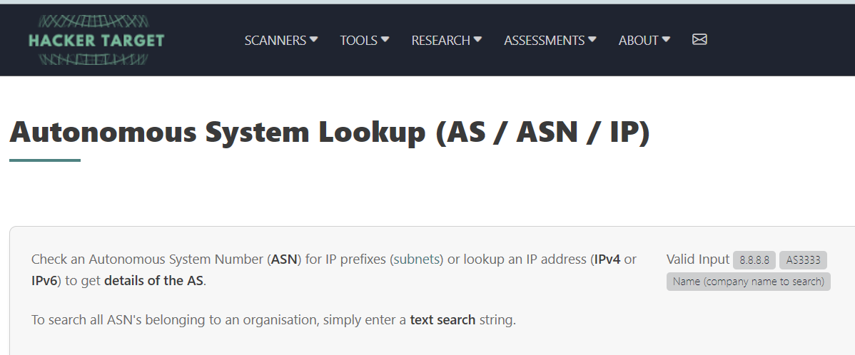



As a participant in this CTF challenge, you will use the HackerTarget ASN IP Lookup tool to perform ASN lookup on given IP addresses. Answer the questions based on the information retrieved from the tool.

**4. Process to Follow while Performing CTF**

**Step 1:** Go to this link <https://traff.co/U9FI0p3l> and copy the ip address.

**Step 2:** Visit the HackerTarget ASN IP Lookup tool using the provided link <https://hackertarget.com/as-ip-lookup/>

**Questions**

**Flag 1: What is the Autonomous System Number (ASN) associated with the IP address 8.8.8.8?**

**Answer:   
ASN: 15169**

**Flag Captured.**

**Flag 2: What is the AS Name associated with the IP address 1.1.1.1?**

**Answer: CLOUDFLARENET**

**Flag Captured.**

Hint

# **Finding Location -**

Use the HackerTarget ASN IP Lookup tool to enter each IP address and retrieve the corresponding ASN and organization information. Pay attention to the details provided by the tool to answer the questions accurately.

